

Лабораторная работа №10
РАБОТА С SERIALIZEBLE ФАЙЛАМИ

Выполнили: студентка группы ИС-24
Пашина Валентина

2026 г.
UnitTest1.cs

using System.IO;
using Microsoft.VisualStudio.TestTools.UnitTesting;

namespace SerializationApp.Tests
{
[TestClass]
public class BusinessLogicTests
{
[TestMethod]
public void Test_TrainSortingByNumber()
{
TrainManager manager = new TrainManager();
manager.Add(new Train("Москва", 102, "12:00"));
manager.Add(new Train("Питер", 15, "15:30"));
manager.Add(new Train("Казань", 88, "08:15"));
manager.SortByNumber();
Assert.AreEqual(15, manager.Trains[0].TrainNumber);
Assert.AreEqual(88, manager.Trains[1].TrainNumber);
Assert.AreEqual(102, manager.Trains[2].TrainNumber);
}
[TestMethod]
public void Test_FindTrainByNumber()
{
TrainManager manager = new TrainManager();
manager.Add(new Train("Москва", 102, "12:00"));
manager.Add(new Train("Питер", 15, "15:30"));
Train found = manager.FindByNumber(15);
Train notFound = manager.FindByNumber(999);
Assert.IsNotNull(found);
Assert.AreEqual("Питер", found.Destination);
Assert.IsNull(notFound);
}
[TestMethod]
public void Test_TrainSerializationAndAppend()
{
string tempFile = Path.Combine(Path.GetTempPath(), "test_trains.dat");
TrainManager manager1 = new TrainManager();
manager1.Add(new Train("Сочи", 55, "10:00"));
manager1.SaveToFile(tempFile);
TrainManager manager2 = new TrainManager();
manager2.Add(new Train("Владивосток", 1, "01:00"));
manager2.LoadAndAppendFromFile(tempFile);
Assert.AreEqual(2, manager2.Trains.Count);
Assert.AreEqual("Владивосток", manager2.Trains[0].Destination);
Assert.AreEqual("Сочи", manager2.Trains[1].Destination);
if (File.Exists(tempFile)) File.Delete(tempFile);
}
[TestMethod]
public void Test_CustomerCardRangeFilter()
{
CustomerManager manager = new CustomerManager();
manager.Add(new Customer("Иванов", "Иван", "Иванович", "Адрес 1", "111122223333", "123"));
manager.Add(new Customer("Петров", "Петр", "Петрович", "Адрес 2", "555566667777", "456"));
manager.Add(new Customer("Сидоров", "Сидор", "Сидорович", "Адрес 3", "999900001111", "789"));
var filtered = manager.GetCustomersByCardRange(200000000000, 600000000000);
Assert.AreEqual(1, filtered.Count);
Assert.AreEqual("Петров", filtered[0].LastName);
}
}
}

Form1.cs
using System;
using System.Windows.Forms;
using System.Drawing;

namespace SerializationApp
{
public partial class Form1 : Form
{
private readonly TrainManager trainManager = new TrainManager();
private readonly CustomerManager customerManager = new CustomerManager();
private readonly string trainFilePath = "trains.dat";
private readonly string customerFilePath = "customers.dat";
private TextBox txtDest, txtTrainNum, txtTime, txtSearchTrainNum;
private ListBox lstTrains;
private TextBox txtLName, txtFName, txtMName, txtAddress, txtCard, txtBank;
private TextBox txtMinCard, txtMaxCard, txtSearchCustName;
private TextBox txtSearchCustCard;
private ListBox lstCustomers;
public Form1()
{
InitializeComponent();
this.Text = "Работа с Serializable файлами";
this.Size = new Size(800, 550);
this.StartPosition = FormStartPosition.CenterScreen;
this.BackColor = Color.LightGray;
InitializeCustomComponents();
}
private void InitializeCustomComponents()
{
TabControl tabControl = new TabControl { Dock = DockStyle.Fill };
TabPage tab1 = new TabPage("Вариант 1: Поезда");
TabPage tab2 = new TabPage("Вариант 2: Покупатели");
#region Инициализация Вкладки 1 (Поезда)
Panel pnl1 = new Panel { Dock = DockStyle.Left, Width = 300, BackColor = Color.WhiteSmoke };
lstTrains = new ListBox { Dock = DockStyle.Fill, BackColor = Color.LightCyan };
pnl1.Controls.Add(new Label { Text = "Пункт назначения:", Top = 10, Left = 10, Width = 120 });
txtDest = new TextBox { Top = 10, Left = 140, Width = 140 };
pnl1.Controls.Add(txtDest);
pnl1.Controls.Add(new Label { Text = "Номер поезда:", Top = 40, Left = 10, Width = 120 });
txtTrainNum = new TextBox { Top = 40, Left = 140, Width = 140 };
pnl1.Controls.Add(txtTrainNum);
pnl1.Controls.Add(new Label { Text = "Время отправления:", Top = 70, Left = 10, Width = 120 });
txtTime = new TextBox { Top = 70, Left = 140, Width = 140 };
pnl1.Controls.Add(txtTime);
Button btnAddTrain = new Button { Text = "Добавить поезд", Top = 110, Left = 10, Width = 270 };
btnAddTrain.Click += BtnAddTrain_Click;
pnl1.Controls.Add(btnAddTrain);
Button btnSortNum = new Button { Text = "Сортировать по номерам", Top = 145, Left = 10, Width = 270 };
btnSortNum.Click += (s, e) => { trainManager.SortByNumber(); UpdateTrainList(); };
pnl1.Controls.Add(btnSortNum);
Button btnSortDest = new Button { Text = "Сортировать по пункту", Top = 180, Left = 10, Width = 270 };
btnSortDest.Click += (s, e) => { trainManager.SortByDestination(); UpdateTrainList(); };
pnl1.Controls.Add(btnSortDest);
pnl1.Controls.Add(new Label { Text = "Поиск по № поезда:", Top = 225, Left = 10, Width = 120 });
txtSearchTrainNum = new TextBox { Top = 225, Left = 140, Width = 140 };
pnl1.Controls.Add(txtSearchTrainNum);
Button btnSearchTrain = new Button { Text = "Найти поезд", Top = 255, Left = 10, Width = 270 };
btnSearchTrain.Click += BtnSearchTrain_Click;
pnl1.Controls.Add(btnSearchTrain);
Button btnSaveTrains = new Button { Text = "Сохранить в файл", Top = 310, Left = 10, Width = 270 };
btnSaveTrains.Click += (s, e) => { trainManager.SaveToFile(trainFilePath); MessageBox.Show("Сохранено!"); };
pnl1.Controls.Add(btnSaveTrains);
Button btnLoadTrains = new Button { Text = "Загрузить и добавить из файла", Top = 345, Left = 10, Width = 270 };
btnLoadTrains.Click += (s, e) => { trainManager.LoadAndAppendFromFile(trainFilePath); UpdateTrainList(); };
pnl1.Controls.Add(btnLoadTrains);
tab1.Controls.Add(lstTrains);
tab1.Controls.Add(pnl1);
#endregion
#region Инициализация Вкладки 2 (Покупатели)
Panel pnl2 = new Panel { Dock = DockStyle.Left, Width = 320, BackColor = Color.WhiteSmoke };
lstCustomers = new ListBox { Dock = DockStyle.Fill, BackColor = Color.LightYellow };
int y = 10;
pnl2.Controls.Add(new Label { Text = "Фамилия:", Top = y, Left = 10, Width = 100 });
txtLName = new TextBox { Top = y, Left = 120, Width = 180 }; pnl2.Controls.Add(txtLName); y += 30;
pnl2.Controls.Add(new Label { Text = "Имя:", Top = y, Left = 10, Width = 100 });
txtFName = new TextBox { Top = y, Left = 120, Width = 180 }; pnl2.Controls.Add(txtFName); y += 30;
pnl2.Controls.Add(new Label { Text = "Отчество:", Top = y, Left = 10, Width = 100 });
txtMName = new TextBox { Top = y, Left = 120, Width = 180 }; pnl2.Controls.Add(txtMName); y += 30;
pnl2.Controls.Add(new Label { Text = "Адрес:", Top = y, Left = 10, Width = 100 });
txtAddress = new TextBox { Top = y, Left = 120, Width = 180 }; pnl2.Controls.Add(txtAddress); y += 30;
pnl2.Controls.Add(new Label { Text = "Номер карты:", Top = y, Left = 10, Width = 100 });
txtCard = new TextBox { Top = y, Left = 120, Width = 180 }; pnl2.Controls.Add(txtCard); y += 30;
pnl2.Controls.Add(new Label { Text = "Номер счета:", Top = y, Left = 10, Width = 100 });
txtBank = new TextBox { Top = y, Left = 120, Width = 180 }; pnl2.Controls.Add(txtBank); y += 35;
Button btnAddCust = new Button { Text = "Добавить покупателя", Top = y, Left = 10, Width = 290 };
btnAddCust.Click += BtnAddCust_Click; pnl2.Controls.Add(btnAddCust); y += 35;
Button btnSortCust = new Button { Text = "Сортировать по алфавиту", Top = y, Left = 10, Width = 290 };
btnSortCust.Click += (s, e) => { customerManager.SortByName(); UpdateCustomerList(); }; pnl2.Controls.Add(btnSortCust); y += 35;
pnl2.Controls.Add(new Label { Text = "Карты от:", Top = y, Left = 10, Width = 60 });
txtMinCard = new TextBox { Top = y, Left = 70, Width = 80 }; pnl2.Controls.Add(txtMinCard);
pnl2.Controls.Add(new Label { Text = "до:", Top = y, Left = 160, Width = 30 });
txtMaxCard = new TextBox { Top = y, Left = 200, Width = 100 }; pnl2.Controls.Add(txtMaxCard); y += 30;
Button btnFilterCards = new Button { Text = "Показать карты в диапазоне", Top = y, Left = 10, Width = 290 };
btnFilterCards.Click += BtnFilterCards_Click; pnl2.Controls.Add(btnFilterCards); y += 35;
pnl2.Controls.Add(new Label { Text = "Поиск по имени:", Top = y, Left = 10, Width = 100 });
txtSearchCustName = new TextBox { Top = y, Left = 120, Width = 180 }; pnl2.Controls.Add(txtSearchCustName); y += 30;
Button btnSearchCustName = new Button { Text = "Найти по имени", Top = y, Left = 10, Width = 290 };
btnSearchCustName.Click += BtnSearchCustName_Click; pnl2.Controls.Add(btnSearchCustName); y += 35;
pnl2.Controls.Add(new Label { Text = "Поиск по № карты:", Top = y, Left = 10, Width = 100 });
txtSearchCustCard = new TextBox { Top = y, Left = 120, Width = 180 }; pnl2.Controls.Add(txtSearchCustCard); y += 30;
Button btnSearchCustCard = new Button { Text = "Найти по № карты", Top = y, Left = 10, Width = 290 };
btnSearchCustCard.Click += BtnSearchCustCard_Click;
pnl2.Controls.Add(btnSearchCustCard); y += 35;
Button btnSaveCust = new Button { Text = "Сохранить покупателей", Top = y, Left = 10, Width = 140 };
btnSaveCust.Click += (s, e) => { customerManager.SaveToFile(customerFilePath); MessageBox.Show("Сохранено!"); };
pnl2.Controls.Add(btnSaveCust);
Button btnLoadCust = new Button { Text = "Загрузить покупателей", Top = y, Left = 160, Width = 140 };
btnLoadCust.Click += (s, e) => { customerManager.LoadAndAppendFromFile(customerFilePath); UpdateCustomerList(); };
pnl2.Controls.Add(btnLoadCust);
tab2.Controls.Add(lstCustomers);
tab2.Controls.Add(pnl2);
#endregion
tabControl.TabPages.Add(tab1);
tabControl.TabPages.Add(tab2);
this.Controls.Add(tabControl);
}
#region Обработчики событий Варианта 1 (Поезда)
private void BtnAddTrain_Click(object sender, EventArgs e)
{
if (int.TryParse(txtTrainNum.Text, out int num) && !string.IsNullOrEmpty(txtDest.Text))
{
trainManager.Add(new Train(txtDest.Text, num, txtTime.Text));
UpdateTrainList();
txtDest.Clear(); txtTrainNum.Clear(); txtTime.Clear();
}
else
{
MessageBox.Show("Заполните корректно поля ввода!", "Ошибка ввода", MessageBoxButtons.OK, MessageBoxIcon.Warning);
}
}
private void BtnSearchTrain_Click(object sender, EventArgs e)
{
if (int.TryParse(txtSearchTrainNum.Text, out int num))
{
Train found = trainManager.FindByNumber(num);
if (found != null)
MessageBox.Show($"Найден поезд:\n{found}", "Результат поиска", MessageBoxButtons.OK, MessageBoxIcon.Information);
else
MessageBox.Show("Поезд с таким номером не найден.", "Результат поиска", MessageBoxButtons.OK, MessageBoxIcon.Information);
}
else
{
MessageBox.Show("Введите корректный номер поезда для поиска.", "Ошибка ввода", MessageBoxButtons.OK, MessageBoxIcon.Warning);
}
}
private void UpdateTrainList()
{
lstTrains.Items.Clear();
foreach (var t in trainManager.Trains)
lstTrains.Items.Add(t);
}
#endregion
#region Обработчики событий Варианта 2 (Покупатели)
private void BtnAddCust_Click(object sender, EventArgs e)
{
if (!string.IsNullOrEmpty(txtLName.Text) && !string.IsNullOrEmpty(txtFName.Text) && !string.IsNullOrEmpty(txtCard.Text))
{
customerManager.Add(new Customer(txtLName.Text, txtFName.Text, txtMName.Text, txtAddress.Text, txtCard.Text, txtBank.Text));
UpdateCustomerList();
txtLName.Clear(); txtFName.Clear(); txtMName.Clear(); txtAddress.Clear(); txtCard.Clear(); txtBank.Clear();
}
else
{
MessageBox.Show("Заполните обязательные поля (Фамилия, Имя, Карта)!", "Ошибка ввода", MessageBoxButtons.OK, MessageBoxIcon.Warning);
}
}
private void BtnFilterCards_Click(object sender, EventArgs e)
{
if (long.TryParse(txtMinCard.Text, out long min) && long.TryParse(txtMaxCard.Text, out long max))
{
var filtered = customerManager.GetCustomersByCardRange(min, max);
lstCustomers.Items.Clear();
if (filtered.Count > 0)
{
foreach (var c in filtered)
lstCustomers.Items.Add(c);
}
else
{
MessageBox.Show("Покупатели в заданном диапазоне карт не найдены.", "Результат поиска", MessageBoxButtons.OK, MessageBoxIcon.Information);
UpdateCustomerList();
}
}
else
{
MessageBox.Show("Введите корректные числовые диапазоны для карт!", "Ошибка ввода", MessageBoxButtons.OK, MessageBoxIcon.Warning);
}
}
private void BtnSearchCustName_Click(object sender, EventArgs e)
{
string query = txtSearchCustName.Text;
if (!string.IsNullOrEmpty(query))
{
var found = customerManager.FindByName(query);
lstCustomers.Items.Clear();
if (found.Count > 0)
{
foreach (var c in found)
lstCustomers.Items.Add(c);
}
else
{
MessageBox.Show("Покупатели с таким именем не найдены.", "Результат поиска", MessageBoxButtons.OK, MessageBoxIcon.Information);
UpdateCustomerList();
}
}
else
{
MessageBox.Show("Введите имя для поиска.", "Ошибка ввода", MessageBoxButtons.OK, MessageBoxIcon.Warning);
}
}
private void BtnSearchCustCard_Click(object sender, EventArgs e)
{
string query = txtSearchCustCard.Text;
if (!string.IsNullOrEmpty(query))
{
Customer found = customerManager.FindByCard(query);
lstCustomers.Items.Clear();
if (found != null)
{
lstCustomers.Items.Add(found);
}
else
{
MessageBox.Show("Покупатель с таким номером карты не найден.", "Результат поиска", MessageBoxButtons.OK, MessageBoxIcon.Information);
UpdateCustomerList();
}
}
else
{
MessageBox.Show("Введите номер карты для поиска.", "Ошибка ввода", MessageBoxButtons.OK, MessageBoxIcon.Warning);
}
}
private void UpdateCustomerList()
{
lstCustomers.Items.Clear();
foreach (var c in customerManager.Customers)
lstCustomers.Items.Add(c);
}
#endregion
private void Form1_Load(object sender, EventArgs e)
{
}
}
}

CustomerManager.cs
using System;
using System.Collections.Generic;
using System.IO;
using System.Linq;
using System.Runtime.Serialization.Formatters.Binary;

namespace SerializationApp
{
public class CustomerManager
{
public List<Customer> Customers { get; set; } = new List<Customer>();

public void Add(Customer customer) => Customers.Add(customer);
public void SortByName()
{
Customers = Customers.OrderBy(c => c.FirstName).ThenBy(c => c.LastName).ToList();
}
public List<Customer> GetCustomersByCardRange(long min, long max)
{
List<Customer> result = new List<Customer>();
foreach (var c in Customers)
{
if (long.TryParse(c.CreditCardNumber, out long cardNum))
{
if (cardNum >= min && cardNum <= max)
result.Add(c);
}
}
return result;
}
public List<Customer> FindByName(string query)
{
return Customers.Where(c => c.FirstName.IndexOf(query, StringComparison.OrdinalIgnoreCase) >= 0 ||
c.LastName.IndexOf(query, StringComparison.OrdinalIgnoreCase) >= 0).ToList();
}
public Customer FindByCard(string cardNum)
{
return Customers.FirstOrDefault(c => c.CreditCardNumber == cardNum);
}
public void SaveToFile(string path)
{
using (FileStream fs = new FileStream(path, FileMode.Create))
{
BinaryFormatter formatter = new BinaryFormatter();
formatter.Serialize(fs, Customers);
}
}
public void LoadAndAppendFromFile(string path)
{
if (!File.Exists(path)) return;

using (FileStream fs = new FileStream(path, FileMode.Open))
{
BinaryFormatter formatter = new BinaryFormatter();
var loadedCustomers = (List<Customer>)formatter.Deserialize(fs);
Customers.AddRange(loadedCustomers);
}
}
}
}

TrainManager
using System;
using System.Collections.Generic;
using System.IO;
using System.Linq;
using System.Runtime.Serialization.Formatters.Binary;

namespace SerializationApp
{
public class TrainManager
{
public List<Train> Trains { get; set; } = new List<Train>();

public void Add(Train train) => Trains.Add(train);
public void SortByNumber()
{
Trains = Trains.OrderBy(t => t.TrainNumber).ToList();
}
public void SortByDestination()
{
Trains = Trains.OrderBy(t => t.Destination).ToList();
}
public Train FindByNumber(int number)
{
return Trains.FirstOrDefault(t => t.TrainNumber == number);
}
public void SaveToFile(string path)
{
using (FileStream fs = new FileStream(path, FileMode.Create))
{
BinaryFormatter formatter = new BinaryFormatter();
formatter.Serialize(fs, Trains);
}
}
public void LoadAndAppendFromFile(string path)
{
if (!File.Exists(path)) return;

using (FileStream fs = new FileStream(path, FileMode.Open))
{
BinaryFormatter formatter = new BinaryFormatter();
var loadedTrains = (List<Train>)formatter.Deserialize(fs);
Trains.AddRange(loadedTrains);
}
}
}
}

Customer.cs
using System;

namespace SerializationApp
{
[Serializable]
public class Customer
{
public string LastName { get; set; }
public string FirstName { get; set; }
public string MiddleName { get; set; }
public string Address { get; set; }
public string CreditCardNumber { get; set; }
public string BankAccountNumber { get; set; }
public Customer() { }
public Customer(string lastName, string firstName, string middleName, string address, string creditCard, string bankAccount)
{
LastName = lastName;
FirstName = firstName;
MiddleName = middleName;
Address = address;
CreditCardNumber = creditCard;
BankAccountNumber = bankAccount;
}
public override string ToString()
{
return $"{LastName} {FirstName[0]}.{MiddleName[0]}. | Карта: {CreditCardNumber} | Адрес: {Address}";
}
}
}

Train.cs
using System;

namespace SerializationApp
{
[Serializable]
public class Train
{
public string Destination { get; set; }
public int TrainNumber { get; set; }
public string DepartureTime { get; set; }
public Train() { }
public Train(string destination, int trainNumber, string departureTime)
{
Destination = destination;
TrainNumber = trainNumber;
DepartureTime = departureTime;
}
public override string ToString()
{
return $"Поезд №{TrainNumber} -> {Destination} (Отправление: {DepartureTime})";
}
}
}

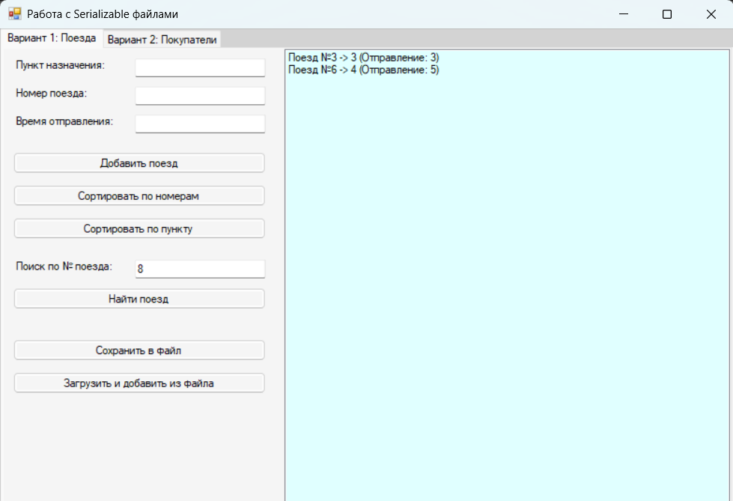
Рис.1 «Результат»

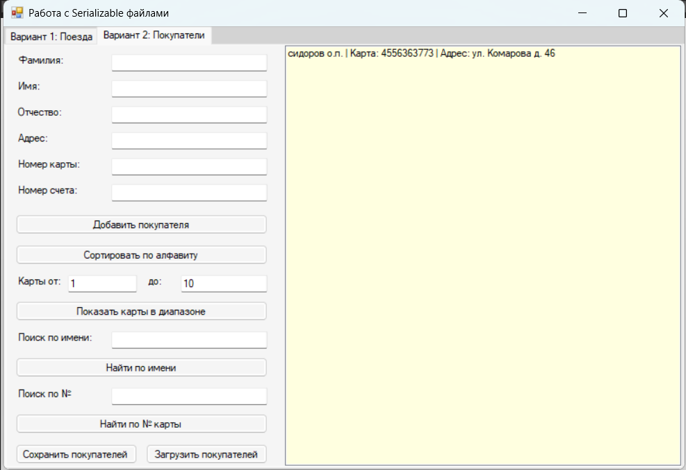
Рис.2 «Результат»

